Mendicity Transmission Project Team REPORT



nATASHA DOWNEY

K00185504

April 2016

Limerick School of Art and Design

Limerick Institute of Technology – Clonmel

A report submitted in partial fulfilment of the requirements for the degree of Bachelor of Science in Creative Multimedia

**Declaration**

This report is my original work and has not been submitted previously for a degree at this or any other institute or university. To the best of my knowledge it does not contain any material published or written by another person, except as acknowledged in the text.

Signed: ___________________________________ Date:_________**Acknowledgements**

This creation of this project would have not been possible without the following individuals valuable help and knowledge. The writer of this report would like to give great thanks to the following people:

John Hannafin – module co-ordinator at LIT/LSAD, for his team management advice, support and guidance from the very beginning of this project.

Mathew Mather - Lecturer at LIT/LSAD, for imparting his expert knowledge around project planning and teamwork strategies relating to the project

Michael Kiely - Lecturer at LIT/LSAD, for his guidance on rendering issues during the duration of this project and valuable feedback.

Bernie Goldbach- Lecturer at LIT/LSAD, for his interesting ideas and out sourced connections relating to this project.

John Tierney – archaeologist, for his knowledgeable insight on Irish history and valuable feedback on the project.

Calvin Cooke- Musician and song writer, for composing the background music for the project.

Eimear King who got a finished version completed for the people down in the Mendicity project, when Natasha did not have her ones fully ready, and for valuable support throughout the whole process of the project.

Claire Murray who completed a unique database and application for the project, also for her valuable feedback and continuous support throughout the process of the project.

Charles – for letting the team have access to the book of transmission to use in the project.

Danny- for taking high quality pictures for the project.

Eiren McLoughlin- for giving great help to Natasha regarding a rendering issue in after effects.

Michael Hennessy - Voice Actor, for doing all the voice overs needed for our project, and for coming back in to record different versions.

**Abstract**

*“The Irish economy is meant to be recovering but July saw homeless families reach record levels”* – The Journal.ie

The Mendicity Project team is a group of tree LIT students who have come together to create a visual audio experience that is enhance by a high quality database application. The team created original content to help raise the awareness of the mendacity intuition that helps greatly with homelessness today.

Our concept originated with a visit to the Mendicity Project Known locally as‘TheMendo’ In existence since 1818. Located in the heart of ‘Old Dublin’ One of Dublin’s oldest charitable institutions Has been helping the poorest in society foalmost200 years. Providing free meals daily and helping people to get

their lives back on track. Our project deals with seemingly eternal problems. Those who applied for transmission were migrants. The same problems

exist today. Homelessness has never gone away; in fact, it is getting worse. Mendo is 200 yrs. old. The work they do deserves to be highlighted.

**Table of Contents**

**Chapter 1**

Report outline

Team Members

Team Roles

**Chapter 2**

Project Management Mythologies

Similar Visual/Audio experiences

Asset Research

Project Pitch

Project Idea

**Chapter 3**

Slap-Comps

Storyboarding

After- Effects

Reaper

**Chapter 4**

Implementation

**Chapter 5**

Evaluation of completed project and team performance

**Chapter 6**

Conclusion

**References**

**Appendices**

Images of project planning

# Introduction

## Report Outline

This report will go in to greater detail regarding the following topics. Team members and their individual roles. The background Research of the project. The Analysis and Design in relation to the project. Implementation of the project. The evaluation of completed project and team performance, the conclusion and finally relevant references and appendices associated with this project.

### Team Members

Claire Murray is currently a third year student, studying creative multimedia in LIT/LSAD She is married with three children. She is very interested in web development and programming, and also in video and photography. She is currently living in Fermoy, County Cork and has some family connections to South Tipperary. This fact makes her very interested in a project regarding the South Tipperary Region.

Eimear King is currently a third year student, studying creative multimedia in LIT/LSAD. She is a mother of two young children. She has a passion for audio and in is very keen in video production. She brings great knowledge to the team as she has a degree in fine arts.

Natasha Downey is currently a third year student, studying creative multimedia in LIT/LSAD. She is a player for the Tipperary ladies football team. She is intrigued by all aspects of video production and has a great interest in helping charitable organisations. This fuels her passion for the project.

#### Team Roles

It was decided at the beginning of the project what section of the project would be completed by various team members. Claire Murray joined the team and had a keen interest in programming. With knowledge of web design and database devilment behind her. The team decided that the development of the database application for the project be managed by her mainly. Eimear King had a strong passion for audio. Given her great enthusiasm when it came to this topic. The team decided that Eimear would manage this aspect of the project but also complete video and asset creation for the project as she had some good skills in these areas also.

Natasha Downey is fascinated with all areas of video production. Taken this into account the team decided that she would manage this aspect of the project. Also having a keen interest in audio. The team decided that she take part in that area of the project also. Overall the team decided to each manage their own sections and also give assistance to each other’s aspects of the project also. This concept really relates to the ethos of the team which is being plugged in. Using this method, the team can plug in all their aspects that could stand alone and also come together as a completed project.

# Background Research

## Project Management Mythologies

The team had a very interesting method of working in terms of a project Management mythology style. Given the various strengths each team member had in relation to the project, the Three Pin Method of Project Management was created. This method was based heavily on the Agile and fluid strategies of project management. The team design this method to enable the project to be modular and scalable in design. To complete this method of management within the team, it was agreed that each member was in management of their key strengths relating to the overall project. Eimear was over the final output of audio in the project. Natasha was in charge of the final video aspects of the project and Claire dealt with the creation of the database application for the project. The team played on each other’s strengths and realised that taking this approach would greatly improve the chance of success for the final project.

.

**Similar visual/audio experiences**

The team looked at experiences that related to the project. Inspiration and more ideas were taken from the research of these experiences. The titanic experience in Cobh greatly influenced the team’s decision making in terms of the overall project outcome. The team originally wanted to create a dynamic video/audio production. On greater research and valuable feedback, the team decided to create an intriguing experience that the audience could immerse in and also interact with the application for the project. The interesting part of the titanic experience in Cobh was they had plenty of interesting information about the titanic itself and facts, the team wanted to assure that the audience understood what the project was about and was left with more interesting knowledge when they finished the experience.

#### Asset research

For the creation of this project it was necessary for the team to gain various assets for the project to be successful. The team all did initial research on old images in Ireland that would relate to the project in some way. The team took in to consideration that there would be copy write issues with using certain images and music. To combat this issue, the team came across free to use imagery and Foley sounds while researching for the project. The team outline pictures that might be needed in the six stories that where been told in the video/audio application experience. By doing this, each team member was able to search independtly and add various interesting images to the image bank folder created on google drive as part of the team project. The team also used the one version of the old paper design asset created by Eimear King in all the videos and also in the application as a template to merge the full experience together in a common style. In regards to the asset research for the music and audio for the project the team first looked at using music that was out of copy write online for the project. Originally the team agreed on this method but after some feedback and greater taught. A team decision was made to source original music for the project that would be unique and more vibrant. The team was lucky to know a musician and song writer, Calvin Cooke who was more than happy to help with the project. The team would like to mention a heartfelt thanks to Calvin Cooke for creating the background music for the project. In relation to researching the Foley sounds needed for our project the team originally planned on recording original pieces for the project. Given unforeseen circumstances and been pushed for time. The team decided to source all Foley sounds from freesound.org. These sounds where then edited in reaper and turned out great in the end.

#### Project Pitch

The original project pitch was presented to the whole third year class and lectures. The pitch consisted of the original idea which was creating a video/audio application experience. At first the team wanted to use actors and costumes to create the story boards for the videos. After a team meeting and feedback from all team members. The team decided to use assets source from online such as old pictures relating to that time to achieve a certain style regarding the project. Overall the lectures liked our original idea and gave us valuable feedback. The team made a more detailed project outline for the lectures as they were somewhat confused about the overall direction of the project. Claire Murray, a valuable asset to the team joined at a later stage which resulted in the project been enhance in a better direction. The team explained this final direction to the lectures and everyone involved in the project was brought up to date. A team of two was now a team of tree and ready to create a dynamic video/audio application experience that each team member was passionate about.

Our aim - to present an Interactive User Experience that transports the audience

back in time, using the experiences recorded in the Book of Transmission to highlight

problems that still exist today, and in doing so to raise the profile of this deserving

organisation through the mediums of, Story-telling, Video production, Audio production, and Interactive Programming.

**Project idea**

The project idea first started when Bernie Goldbach a lecturer at LIT, planted the seed about the Mendicity Institution in Dublin. Eimear King and Natasha Downey went up to visit the intuition and by meeting the people that manage it and getting to see the book of transmission, ideas where discussed around and a project idea was created. The team started brainstorming ideas right away and came up with a similar style for what the overall project aims and outcome should be. Once the team had a solid idea of what the project should be they then got advice from Lecturer Mike Kiely. The team got great feedback on how to go about tackling this project. Overall the team was satisfied that Mike Kiely liked our idea and taught it was very feasible. This pushed the team in a positive direction in relation to the project idea. When the team received a valuable team member Claire Murray, the team decided to enhance the original idea for the project even further, given Claire’s strong programming skills and keen interest in database development. The idea for the database application to compliment the original idea of the audio/video experience was created. The team was very satisfied with the final project idea and as a result every team member was enthusiastic to get started into this project.

# Analysis and Design

## Slap-Comps

The team agrees that this area of the project was very beneficial in finding an overall design for the project. When Eimear and Natasha separately went away and brought their storyboards into a slap-comp version in after effects, a design for the project was then created. The team found that when they looked at each other’s versions of the slap-comps they were on the same wave link with using old imagery to create a historic effect video. The original design idea of using actors was then removed from the project plan. The team all agreed that this new found style of still imagery was more pleasing to look at and related more to the stories that the team was trying to convey from the book of transmission. Removing the actors from the project also made the completion of the project more feasible as a result of this decision.

## Storyboarding

In relation to the audio/video aspects of this project, the author of this report was greatly involved. Getting started the team focused greatly on storyboarding ideas for the project. The team had 6 stories from the book of transmission which they wanted to convey as an experience using video, audio and a database application. The ideas for the 6 stories where split up between two team members who were more interested in the motion graphic skill sets. The storyboard ideas where left to one team member who was keen on very interested in the programming side of development. Each team member created storyboards for their part in the project. Eimear King had sketched out her tree storyboards for the tree stories she had chosen. Natasha also had sketched out her tree storyboards for the tree stories she had chosen. Claire had sketched out design idea for what the overall database and project would look like. The team came together at a team meeting with all their design ideas for the project. The team was very satisfied as every team member seemed to be on the same page in regards to the style and design of the project. After completing the storyboards and having a team meeting, the team was happy to move on in this positive direction to create the project. After the team gave the go ahead, every team member was free to continue with the design of the project and finish the final storyboard.

### After effects

The main platform for creating the videos was Adobe After effects. The two team members involved in creating the videos for the project where very familiar with this software and knew how to use it to benefit the project. Adobe Photoshop was also used greatly to manipulate the images been used in the project. By bringing every image into Photoshop the team could get rid of any defects. The images been used where very old and required a good bit of touching up if they were to be used in the project. Adobe Photoshop also helped greatly when it came to masking out certain assets and elements from images for use in the project. After analysing this aspect of the project the team decided these platforms where best to use in the creation of the project. The tasks of masking out every individual images were a daunting task but once the team got into the flow it was more manageable as the teams work flow got faster as the team progressed.

#### reaper

The team decided to use reaper, which is a popular sound editor. The team taught it was more financially feasible to use the free version for the project which let the team do everything they wanted to do in regards to editing the audio been used in the project. The team found the features in this software to be very useful in terms of enhancing voice overs and creating loops of music.

# Implementation

This section will try to convey how the team implemented the project.

The project began when the seed was planted after two of the three team members visited the Mendicity Intuition in Dublin. After the team had seen the book of transmission and talked to the people that run this organisation. The idea to create a visual/audio experience was born. The team wanted to help raise awareness of the good work that this organisation does. The team also wanted to enhance their motion graphics skills. The opportunity to create a dynamic visual/audio application experience that the team could use in their personal portfolios was also a key motivator. At first there was only two member involved in the project. Eimear and Natasha first started the implementation of the project by brainstorming ideas for the book of transmission. After getting valuable feedback on the amount of time the team had to complete the project. The team decided that taking on six stories from the book which had over hundreds was the most feasible action. The team decided to brainstorm out the project idea, regarding the experience itself, the room design for the experience was designed and also how the team wanted the overall outcome to be in terms of visual and audio assets within the room. It was still early on in the project when the team gained a valuable team member Claire Murray. Claire brought a unique insight in the terms of programming and interactive application development. After the team had gained a third member it was decided that the project was to be enhance and made more dynamic with these new found skills Claire had brought to the table. The team decided to have a meeting to re- design the project in away and bring everyone up to speed so the team could move forward. It was decided that a database application was to be created to complement and enhance the original video/audio experience. The team came up with the concept of logging all the stories from the book of transmission while also highlighting the mendacity intuition itself using the application that was to be created. The team planned to have this application run and tablets and be on display along with the visual/audio elements as one overall experience. To help with the overall implementation of the project the team decided to use google drive and WhatsApp messenger to stay in contact. Every team member was very busy and had outside personal issues along with various other college projects to complete. Realising this at the start, the team decided to keep up to date with each other on WhatsApp. Google drive was very useful for the team. This application allowed the team to quickly see each other’s work from home and access various assets. It was very un-realistic for the whole team to be in the college all the time. Google drive helped greatly as it let the team share content and see the overall progress of the project. The team caught up with each other in relation to the project in the team project classes. Overall for the implementation of the project the team used their project plan as a guideline to get their project goals achieved. At the start the project plan was up in the air. Natasha Downey was initially in charge of creating a project plan, after three different attempts at making a project plan, it was decided to work together as a team and create a new plan that every team member understood and could follow clearly. Using this new project plan which allowed the team to see every weekly task that needed to be completed was very useful. The team found that there was a lot of changes throughout the project plan given out of the teams control circumstances. Been able to quickly add tasks due to these stages and take certain tasks away gave the team a clear status of where they were in regards to the project and what could be completed in the time remaining. Once the project plan was clearly outlined among the team members the overall work flow was faster as a result. Each team member began working on their section of the project. Eimear and Natasha took on the Audio and visual elements. This involved masking out each image to be used in the videos using Photoshop. Photoshop was also used to enhance these images to a much higher quality than the originals. Once all the images where edited and up to an agreeable standard the team could then use them in the creation of the six videos. Claire was very busy working on the development of the database application. The whole team gave feedback on the design of the applications wireframes before it was put in to production. The implementation of creating the overall experience was completed in manageable steps. Firstly, all the brainstorming was completed. Then the assets such as images and webpage designs where brought into the production process. The team found the production process very slow at the beginning as they were still not familiar with the routine. After the second week the team was in a great work flow and completed the same tasks as before but much faster. Eimear and Natasha where getting faster at masking out every individual image and Claire was getting much faster at putting the pages for the application together. The team was noticing how fast it was all coming together. Creating the videos for the project was quiet intense. The team found that they were going back constantly to enhance the quality of one video before moving on to the next. The team faced two big issues regarding the project. The first was swapping over from one software to another in relation to creating the database application. Claire found that the original software she had chosen to use was giving her a good search design for the database itself. In regards to other features this software was lacking complexity so Claire decided to use a more dynamic software. Learning all the features for this software was a difficult task that Claire completed very well. The second issue that arose in the project was having trouble with the rendering of the videos. The team realises that team member had different settings on their compositions and as a result the videos did not match. To overcome this the team got together and match up all of their settings so that they were the same. This had a domino effect and resulting in enhancing all the videos again to fit into the new composition settings in after effects. Once this obstacle was cleared another issue arose regarding rendering out the videos. When the audio was added the videos seemed to be very slow and did not run properly. The team got advice of Lecturer Mike Kiely and his advice to render out all the compositions as mp4 helped. Natasha had trouble rendering out her videos for the project. Everything seem to be in working order but when the videos rendered out with the audio they were not of great quality and the audio was freezing. Given that the project was due Monday and Natasha could not get into the college to try render the videos out again on Saturday as she had to complete a video assessment in thurles as part of a different module. The only solution for this issue, was to go in early Monday morning and try to get the videos rendered out in time for the deadline. Then Natasha would put all the videos together as one project for submission. Overall the implantation for the project went considerably well given the unforeseen circumstances various team members had to face.

**Evaluation of Completed Project and Team Performance**

Given that the team had various setbacks regarding personally issues and rendering issues. The project turned out very well. The audio aspect of the project was quite successful. The voice overs where done a second time and this resulted in higher quality versions being used in the project. Given that the Foley sounds where edited in Reaper, the overall quality was quite pleasing. The final output of the audio/video product was very successful. Given the positive feedback from John Tierney regarding the team’s final project. The team was very pleased with the work they had completed. The database application overall was very dynamic in design and it’s features. The style fitted in perfectly with the audio/video aspects of the project. The team created the overall project goal which was a dynamic audio/video application experience. There was a number of issues with our team. With the circumstances of Claire not been able to be at the college …

# Conclusion

In this section the author will try to convey their personal experience of being part of this project. The obstacles that where faced and how set obstacles where overcome. The key learning that the author can take on in the creation of future projects. The overall opinion on how the project turned out in the end.

The author of this report found that being part of a team that had a common goal was a key motivator in getting work completed to a high standard. The support that was had throughout the initial start of the project was very strong among the team. The support did fall greatly towards the end within the team. The author would like to highlight that this was not the other two team members fault as they had various family and personally issues arise that needed to be taken care of at this time. Due to these circumstances the author found that she was working alone on the project and could not communicate as freely as she would have liked to if circumstances where different. A valuable lesson was gained through experiencing this obstacle. It taught the author that life can throw un expected events in the way of workflow. Given that the team had a strong ethos and management style, the author could follow these guidelines that where set out at the beginning. Following the original project plan was great at the start, but as events un folded. the team had to learn to quickly adapt to change so that a high quality project could be still completed in the end. With the author feeling a lack of support from the team her work flow was effected, as she could not but help be worried for her team mates and their well-fair. Eimear had to face many obstacles throughout the project relating to family issues. Trying to balance her life at home, other assignments and this project. She still managed to overcome the technical issues with the project and created three high quality videos and audio sound scrapes for the project and was always there for support when she was capable of lending a hand. Claire had to be at home a lot during this project to take care of family affairs and managed and created an impressive database application for the project. This database application was very difficult to achieve but she pulled through in the end with hard work.

Natasha felt a lack of support from the team as they were not at the college as much as she would of like, no fault of their own. Natasha fully understands the circumstances of the other team mates and is happy she had the opportunity to be part of a caring and hardworking team. Natasha completed three videos with audio soundscapes for the project. She had rendering issues near the end and when the audio was added in to the videos this left them to be not time out right and working to a standard she would of liked. Given the deadline approaching Natasha will have to submit the files that she has completed currently. The teams overall aim is to have the whole project fully working to showcase in the demo. The team plan on even working harder during the next few weeks to achieve the experience they wanted for the project at the upcoming event pen and pixel. Given the obstacles and changes that the team had to adapt to, the team is overall satisfied with the process of being part of this project. The team feels that they learnt a lot about the actual time it takes to complete tasks relating to the project. What can go wrong with a project was greatly highlighted within our team and resulted in a positive learning outcome. The team would love to minimise the stress levels the next time around and look forward to working on future projects in the nearby future. The author has learned that communication within a team project is very important and used this key learning to benefit the project in the final stages as she sought out to get advice on the production of her videos from her team mates. The author realises that if her communication skills where stronger at the beginning a lot of the technical issue that appeared in relation to the project would have been overcome a lot quicker with less stress involved. The author feels that she left the team down in the beginning of the project and is now very aware of where she needs to improve regarding time management and overall communication skills. The author also reflects greatly on her organisational skills and now knows that more time should be allocated for the write-up of the team report. The author was under great pressure to get the team report completed in time due to poor time management skills.

**References**

*“The Irish economy is meant to be recovering but July saw homeless families reach record levels”* – The Journal.ie

**Appendices**

**Room Plan<image1>**

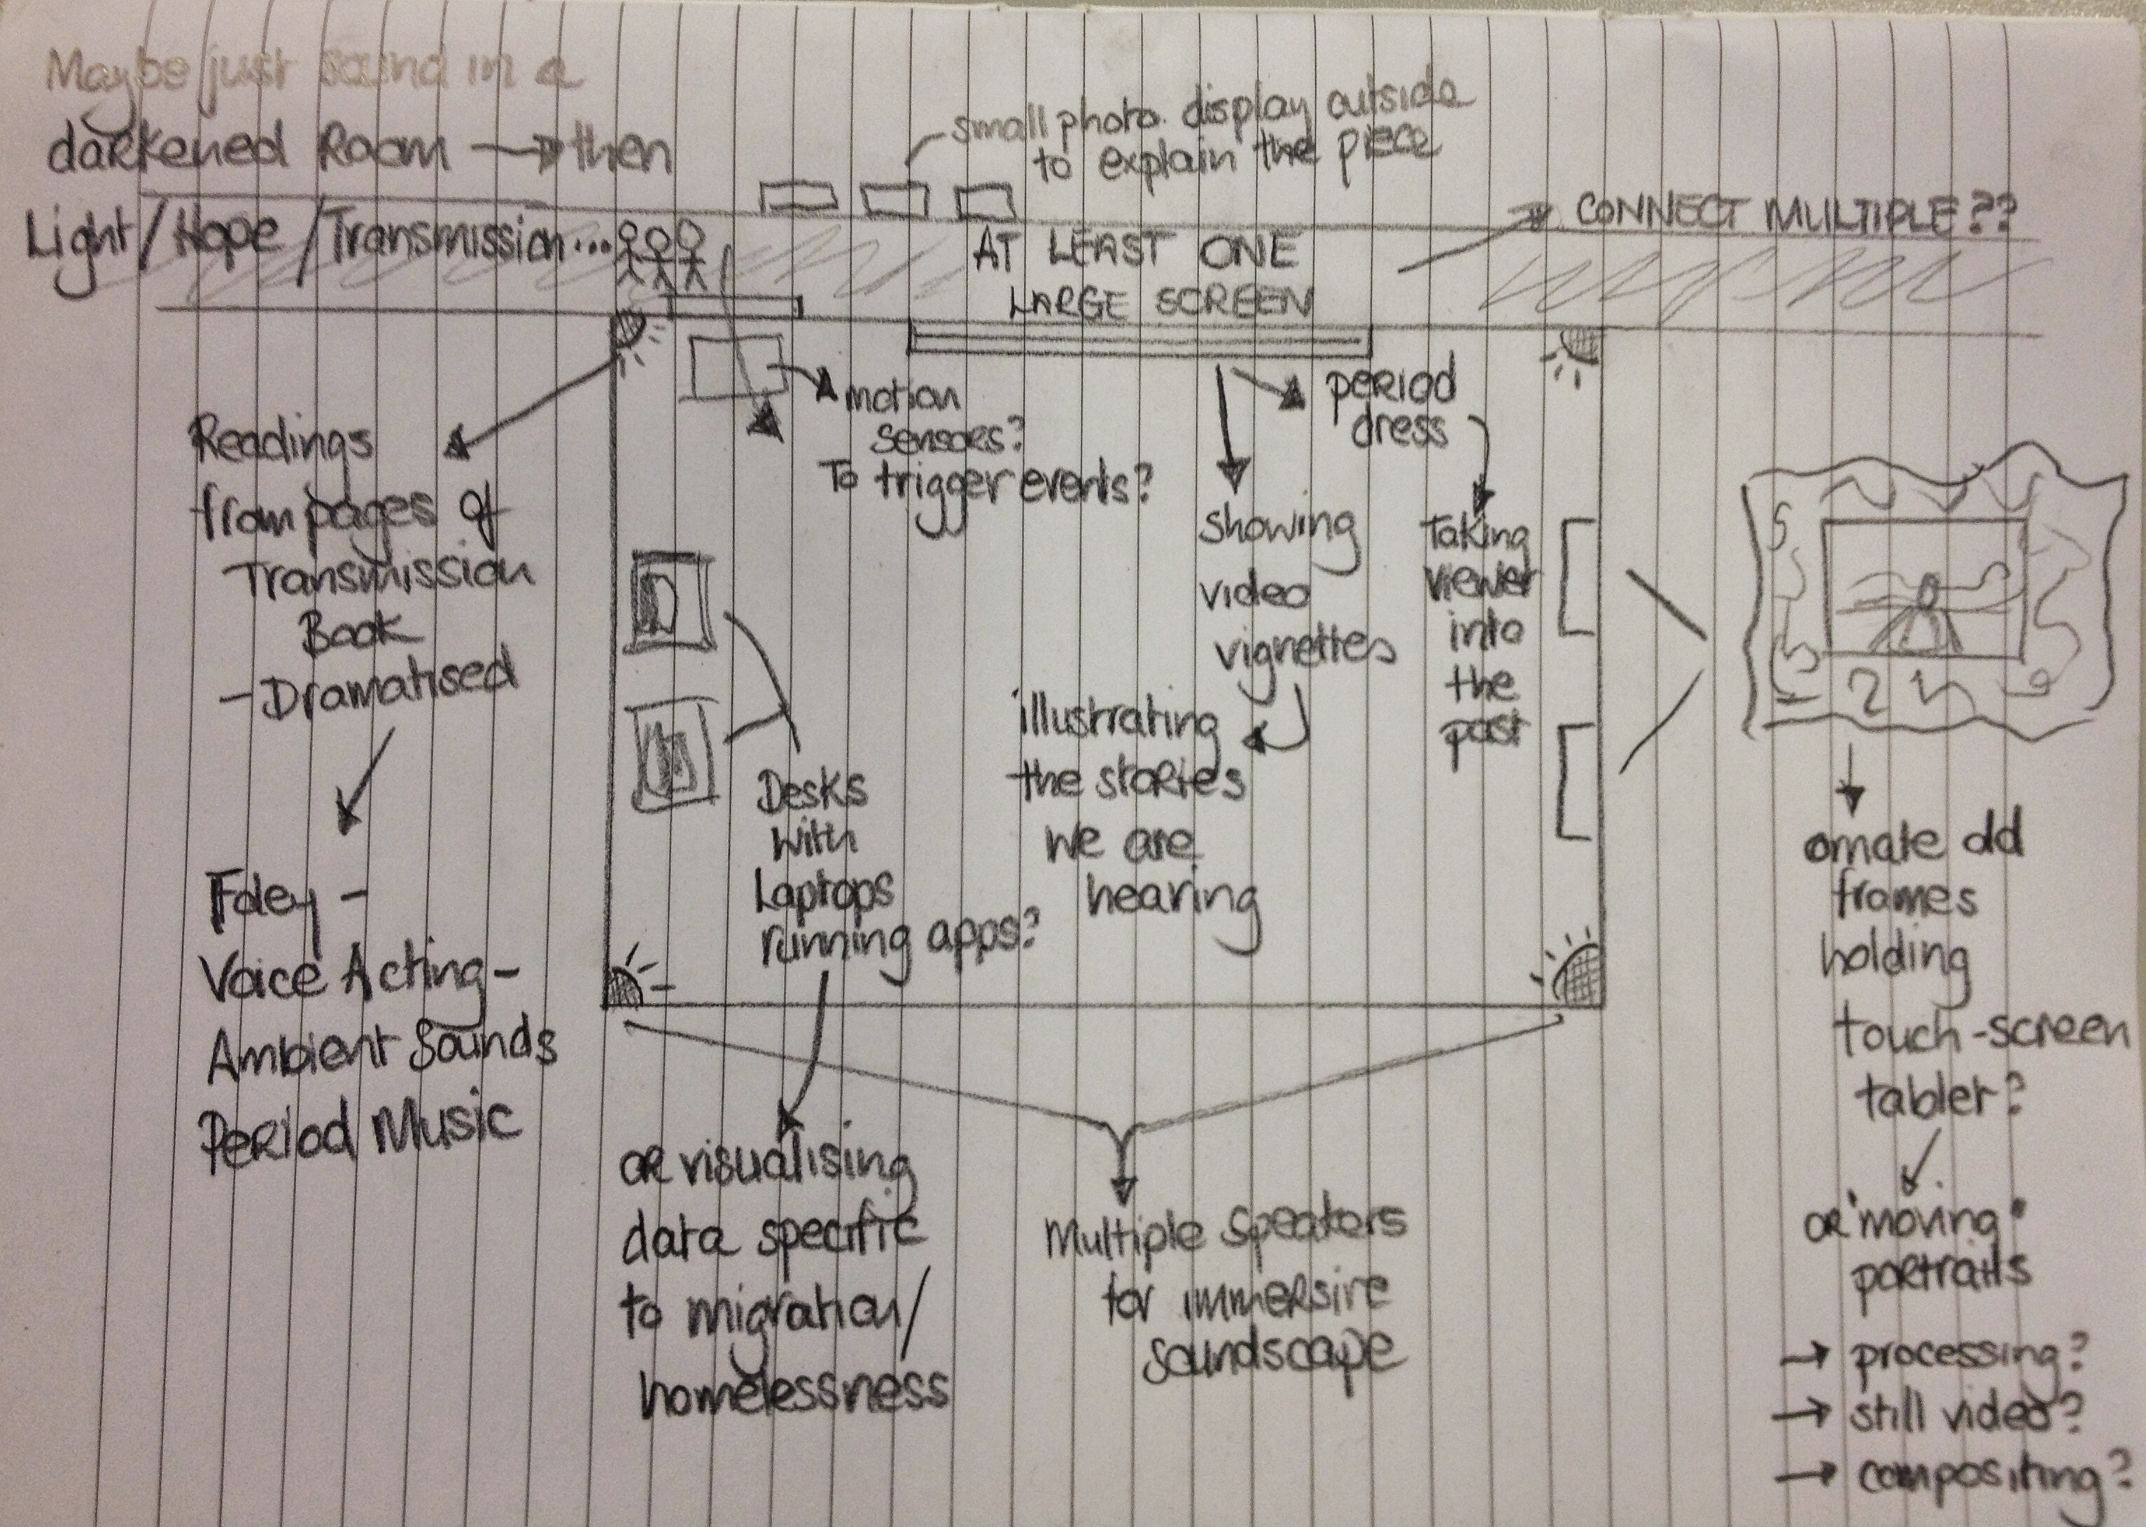

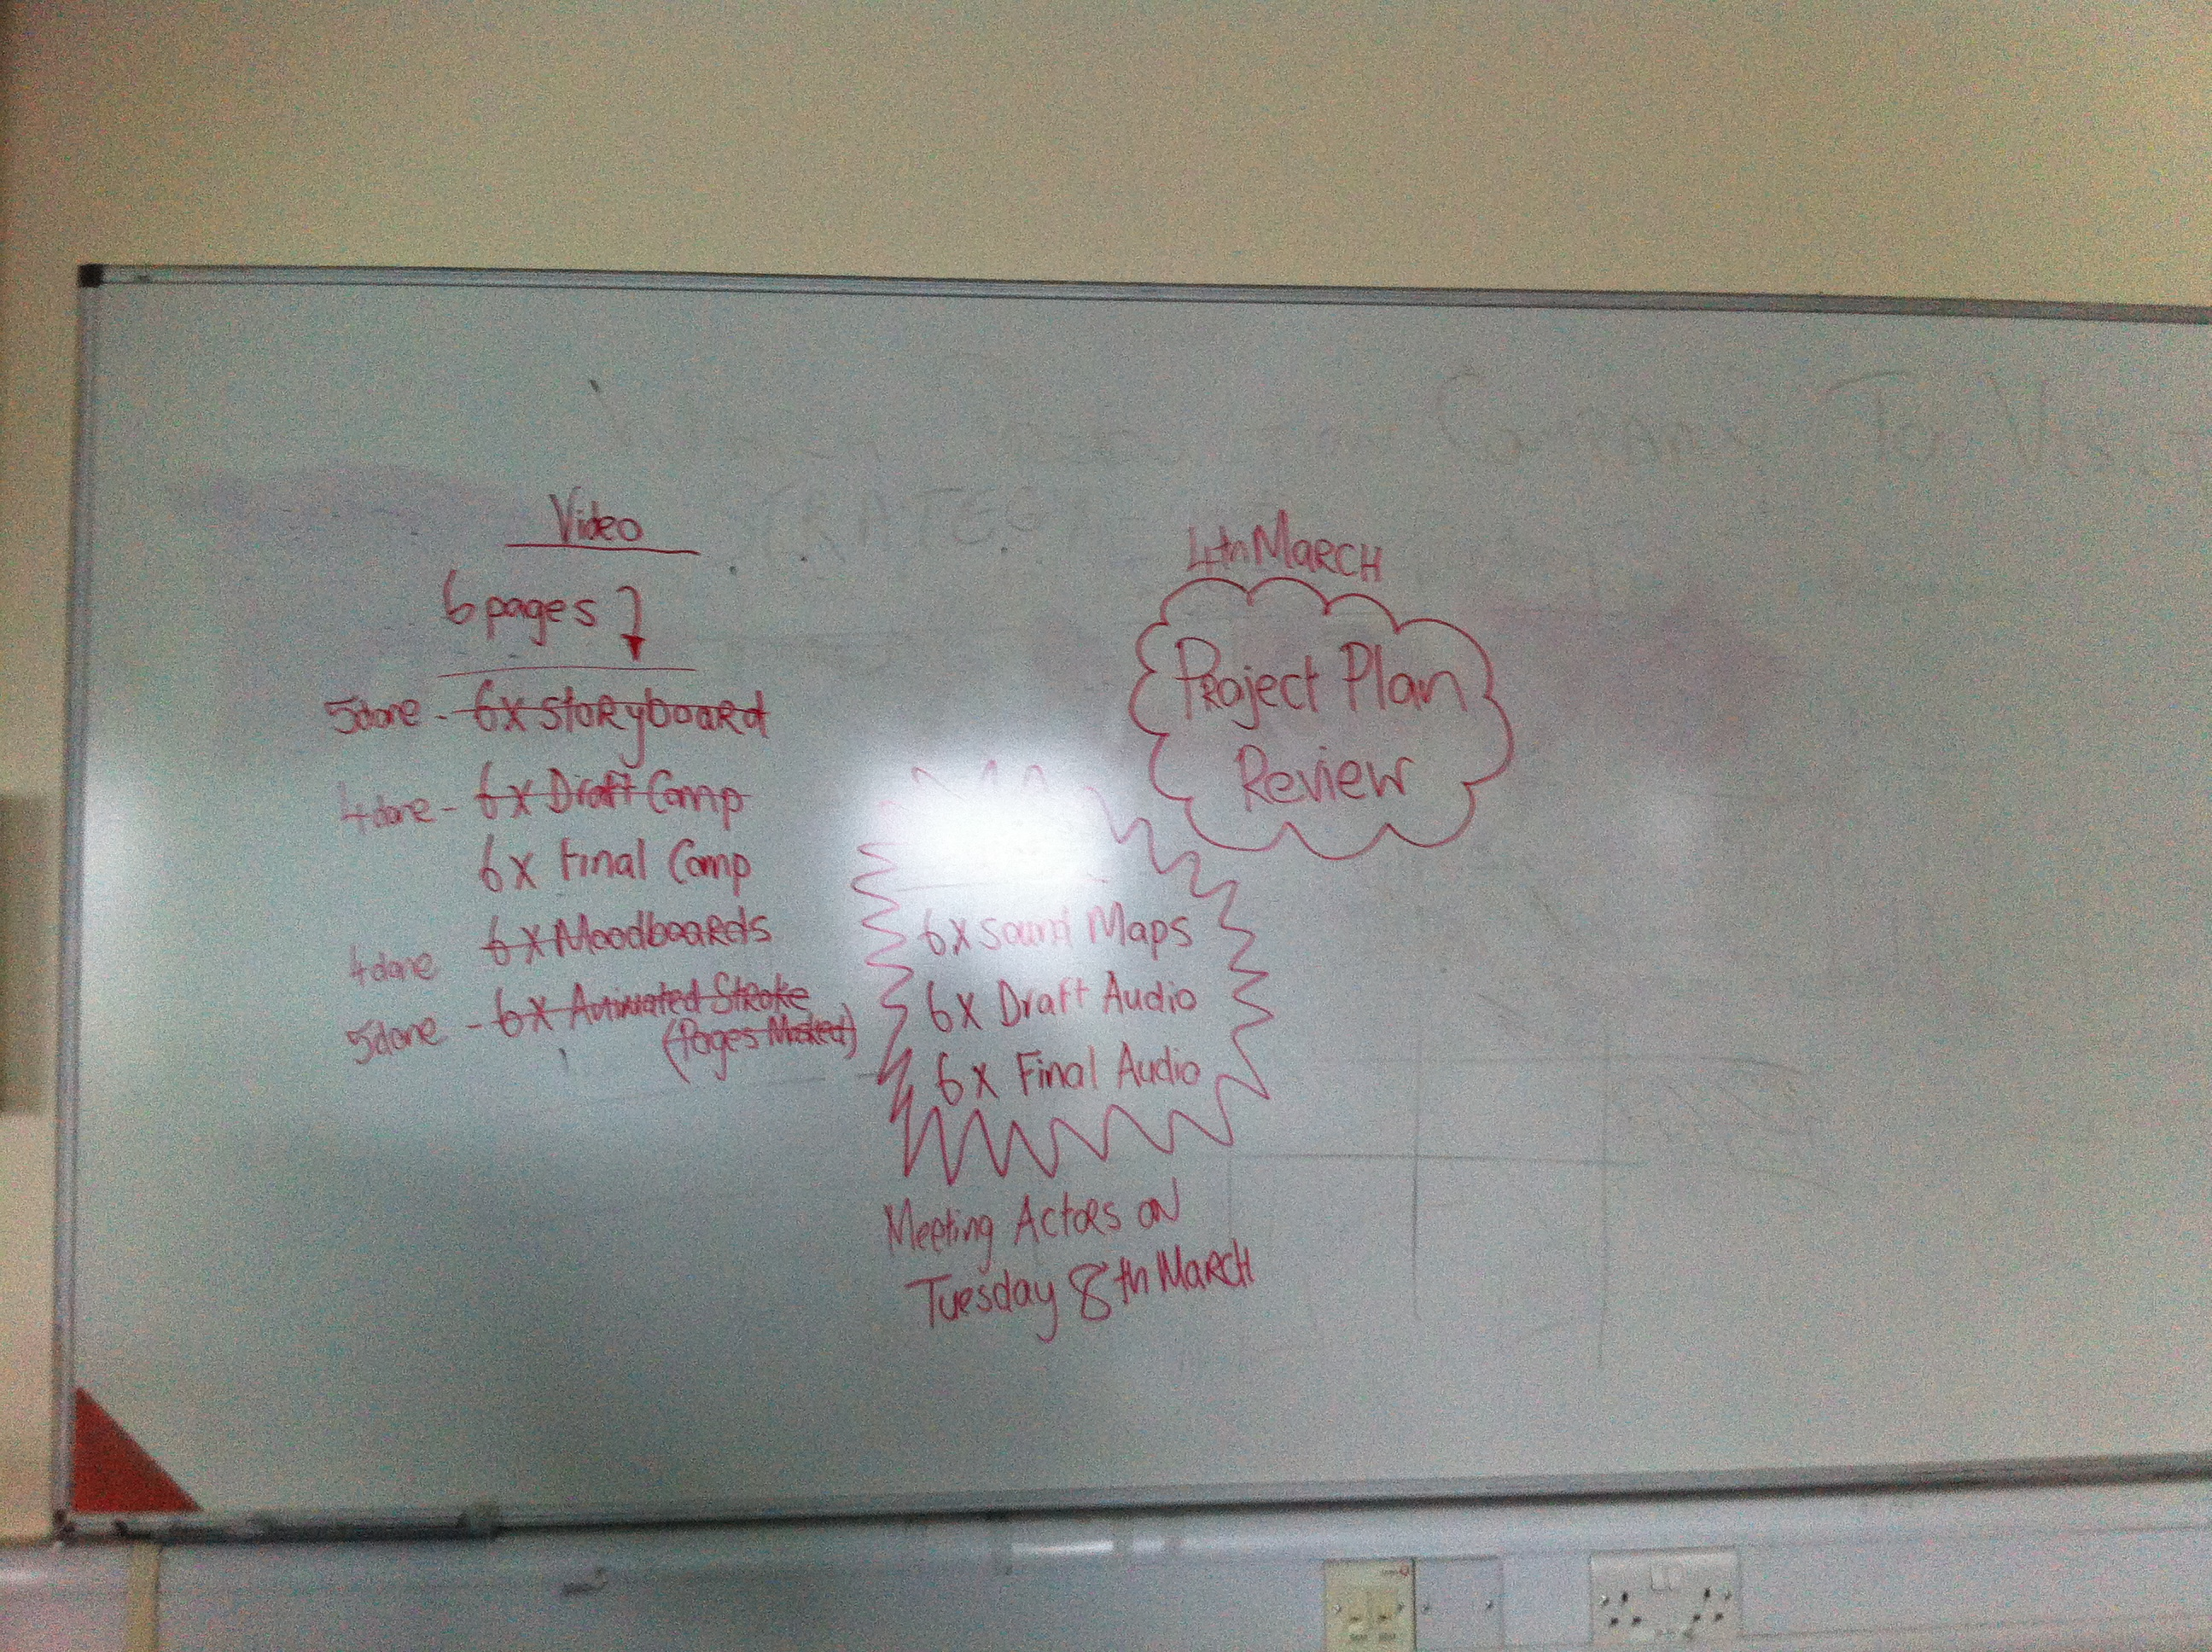**Project plan Brainstorm<image2>**

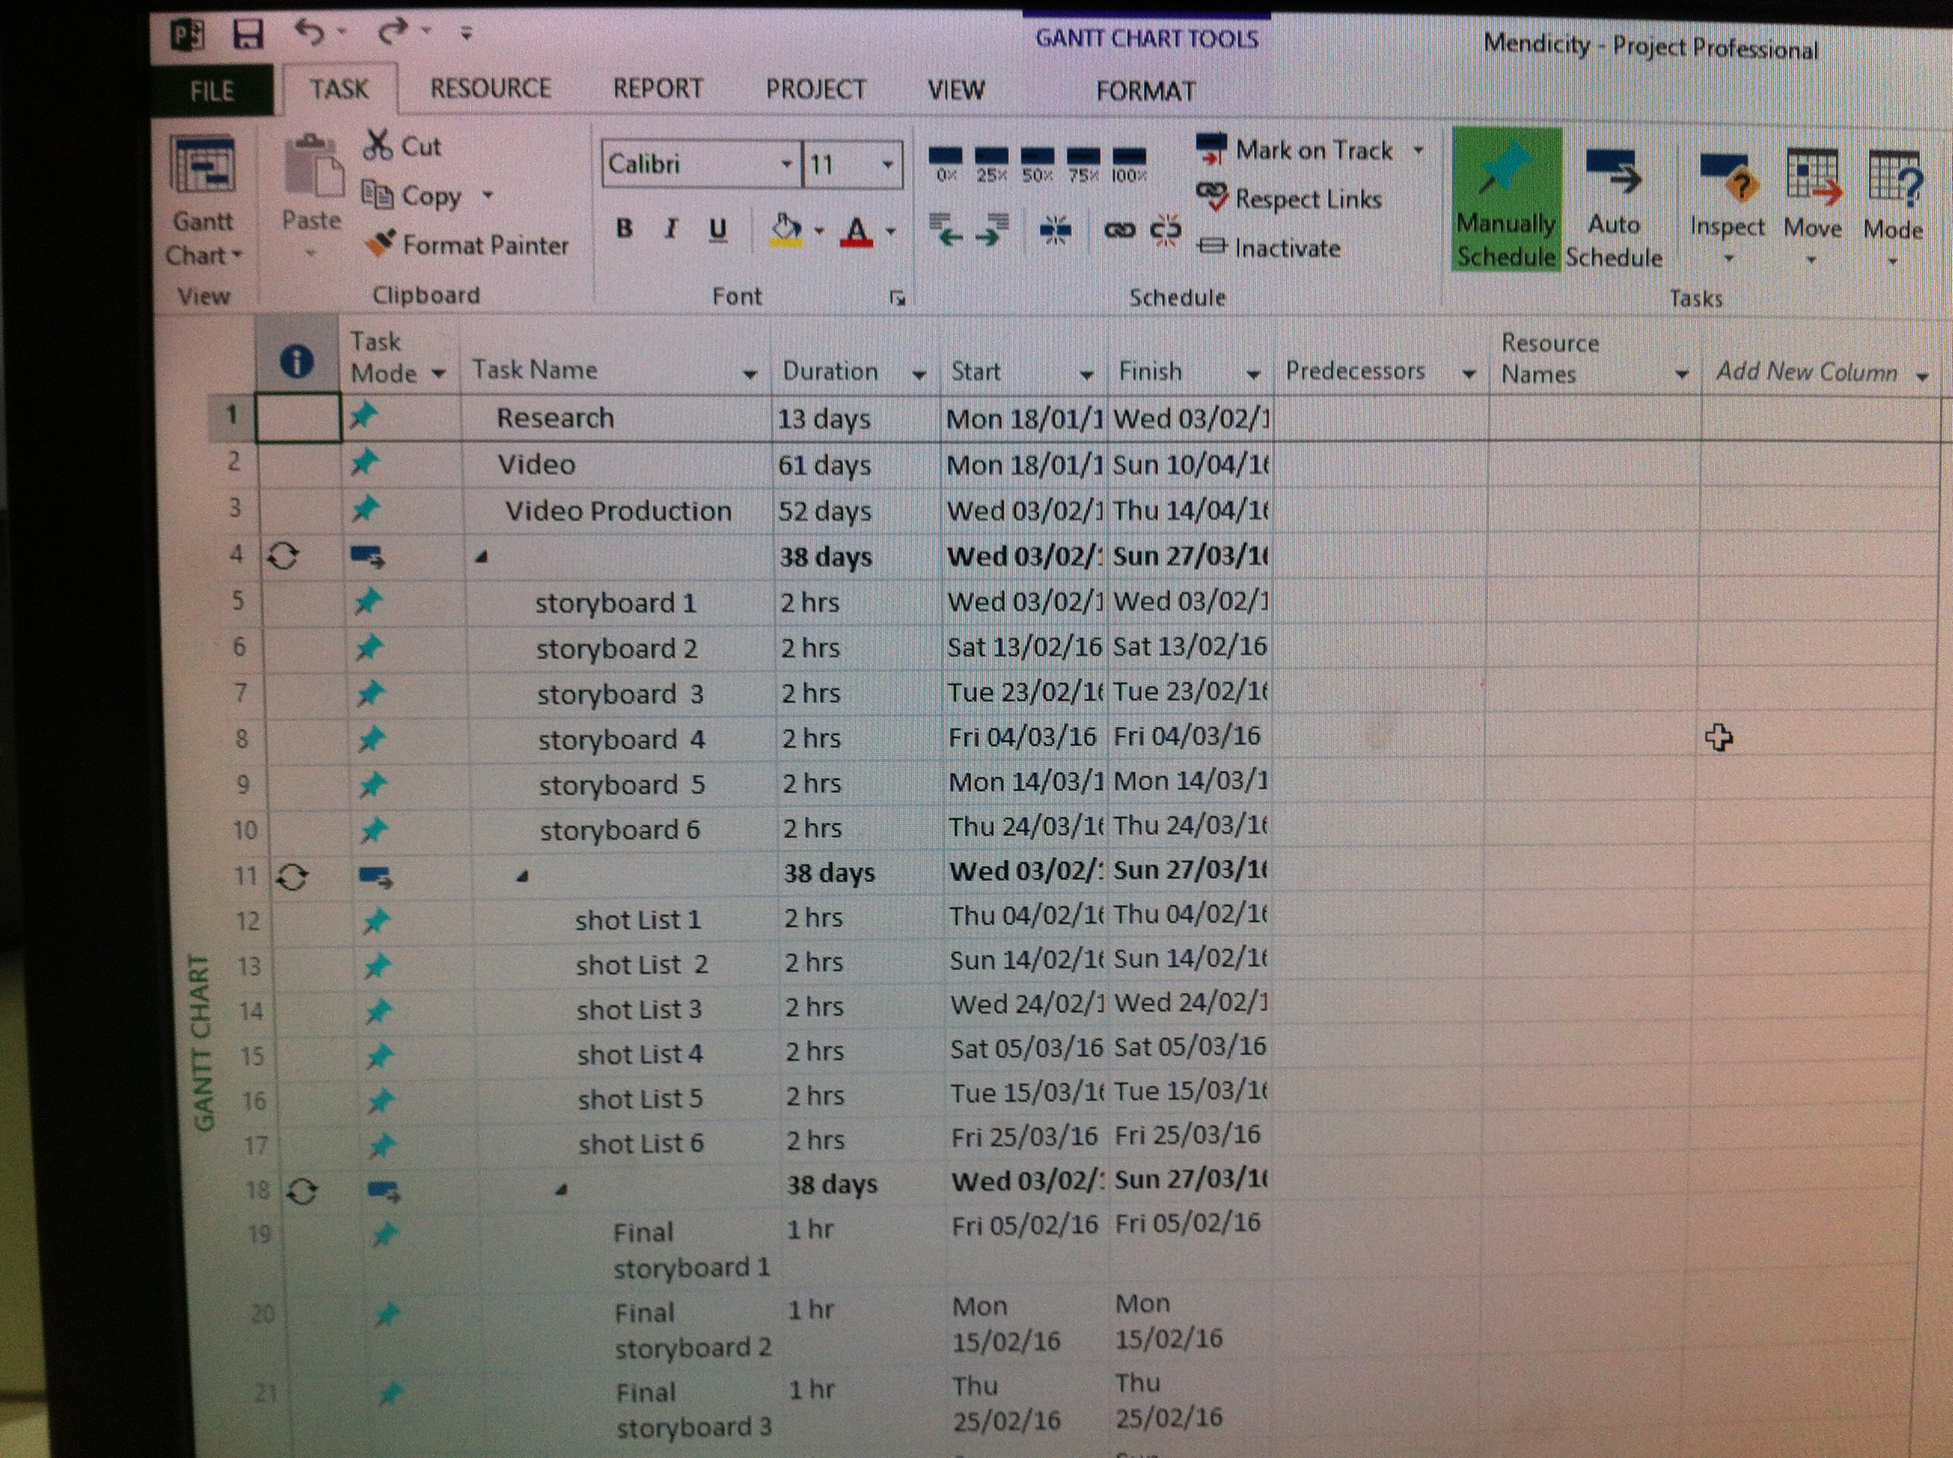

**Project Plan <image3>**